• Lab Title: Lab 2: HTML Injection

• Assignment Title: Lab 2: HTML Injection
• Student Name: Bashir Adam
• Student ID: 2025/FWSD/11509
• Course Name: BVWS103– OWASP-Top-10-Vulnerabilities-Exploitationentials
• Instructor Name: Aminu Idris
• Date of Submission: 23 JAN, 2026
• Version: Version 2.2.0

LAB OVERVIEW/OBJECTIVE

Objective:
In this assignment, you will:
- Understand HTML injection vulnerabilities and how they work.
- Learn how an attacker can exploit HTML injection.
- Apply mitigation techniques to prevent HTML injection vulnerabilities in your web applications.

Task 1: Exploit HTML Injection Vulnerability

After starting my system i run lunch my XAMPP and navigate to the htdocs directory and create index.php and server.php file
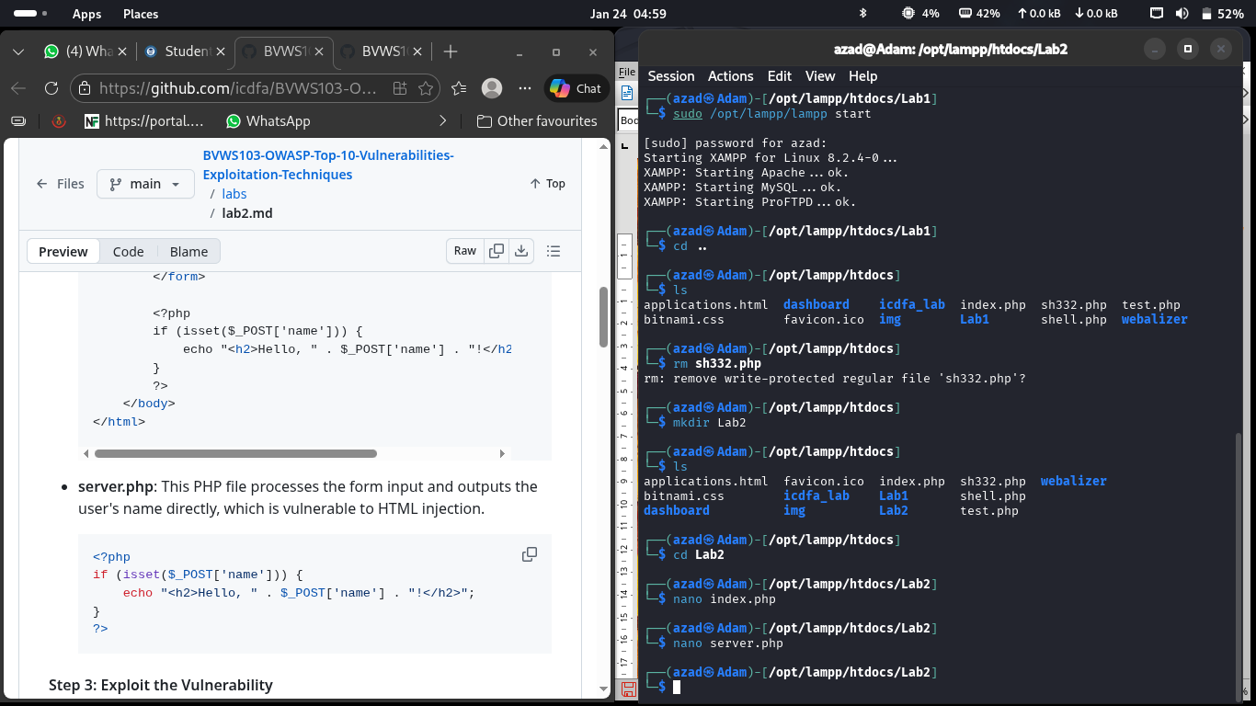
The index.php file
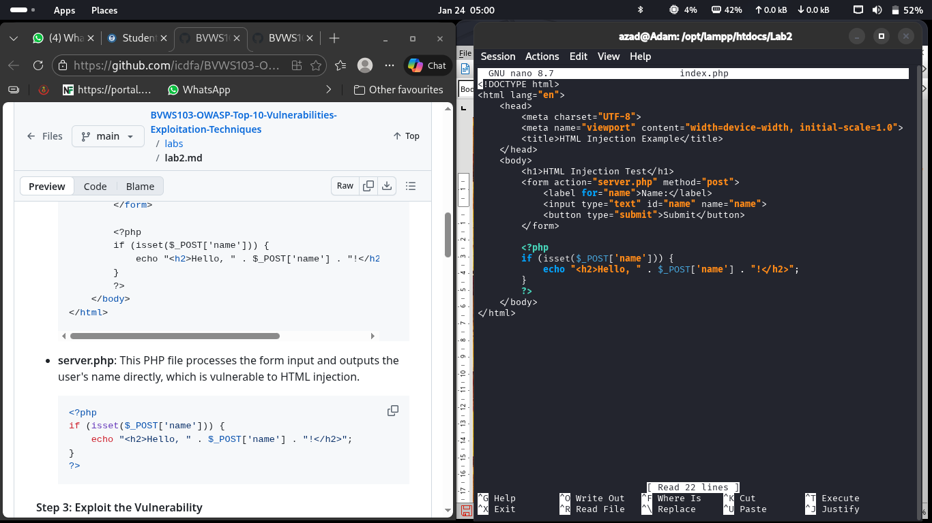

The server.php
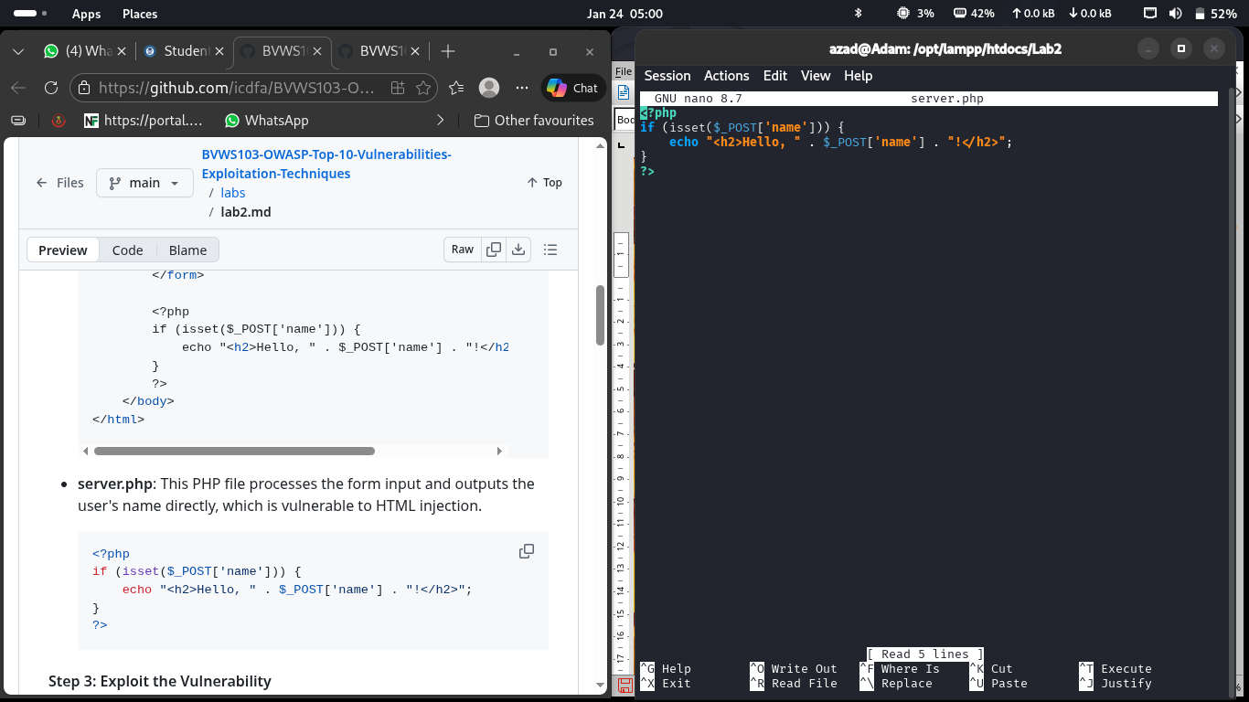

The output of the volnerable applications
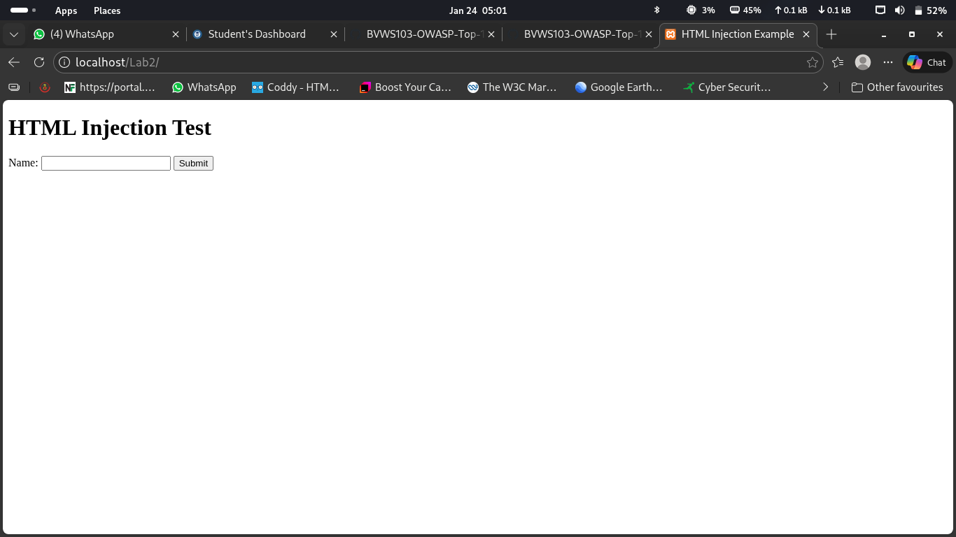

I inject an html injection “<script>alert('Hacked!');</script>” and it exacute the webapp
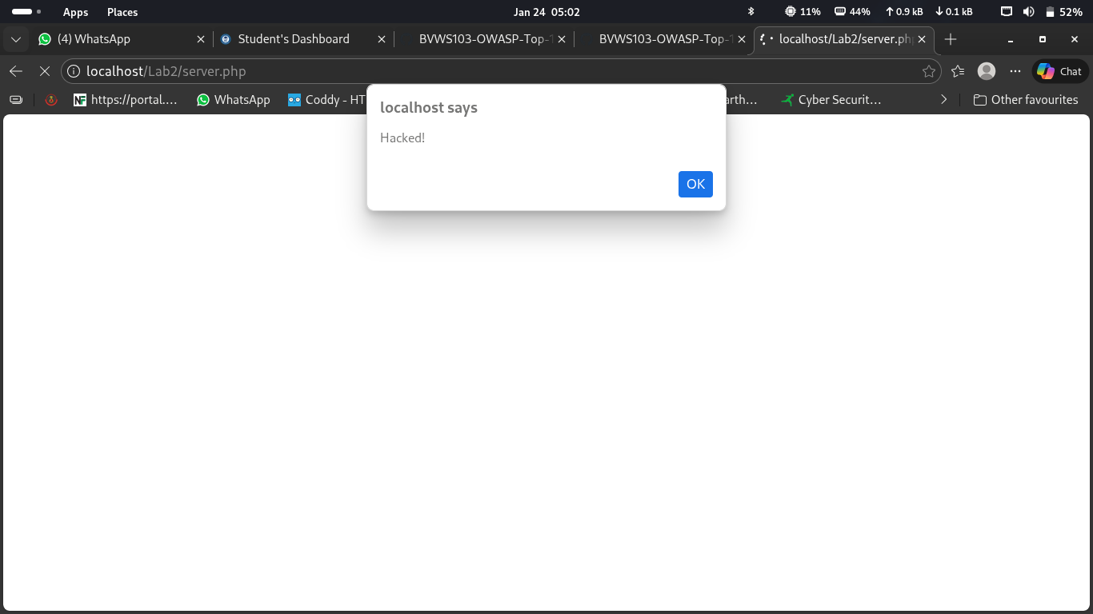

1. Why does this code allow the JavaScript to execute?
The JavaScript code executes because the web page does not properly validate user input before displaying it on the page. When the script

2. What potential risks does this vulnerability pose in a real-world application?
This vulnerability can be very dangerous in real-world applications because attackers can inject malicious scripts that can:
- Steal user information
- Impersonate users
- Deface websites
- Spread malware or phishing attacks
- Damage an organization’s reputation and trust

Task 2: Mitigate HTML Injection Vulnerability
I Modify the server.php file and then include the following sanitization technique:
<?php
if (isset($_POST['name'])) {
$safe_name = htmlspecialchars($_POST['name'], ENT_QUOTES, 'UTF-8');
echo "<h2>Hello, $safe_name!</h2>";
}
?>

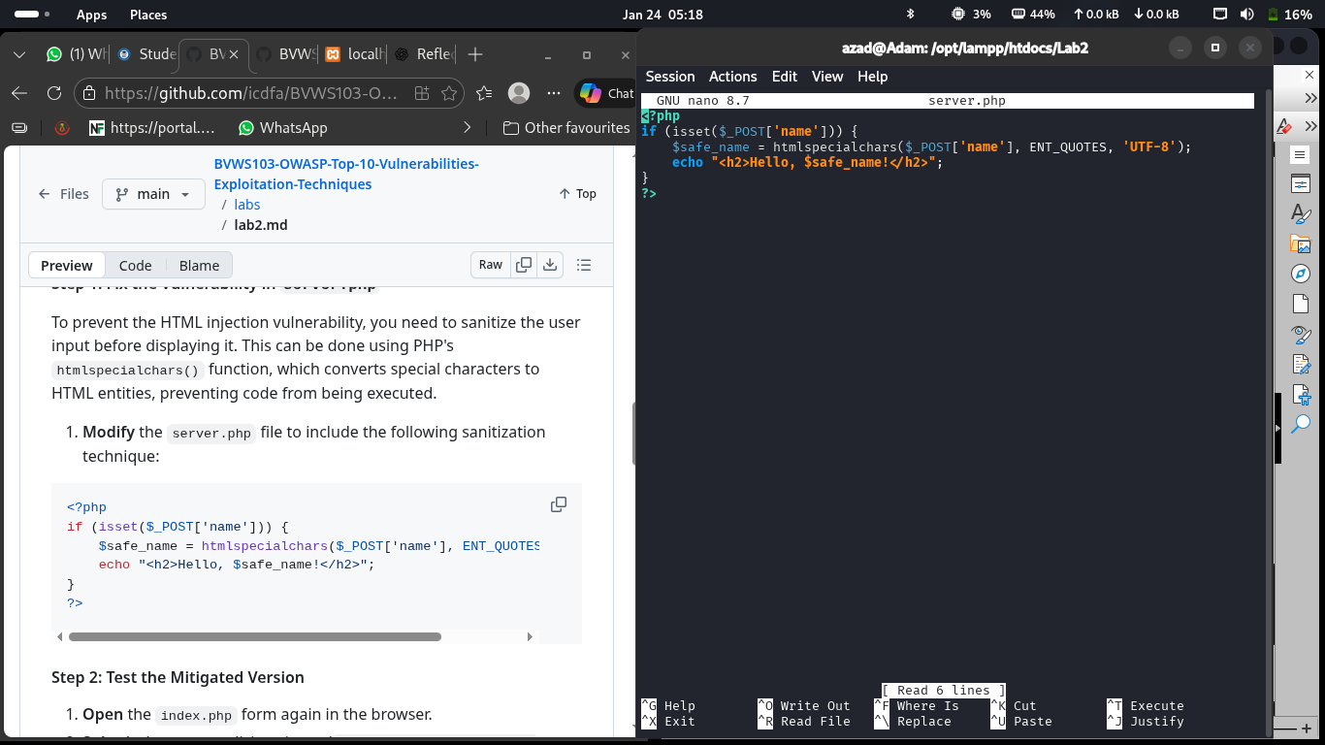

I then Submit the same malicious input <script>alert('Hacked!');</script> again.
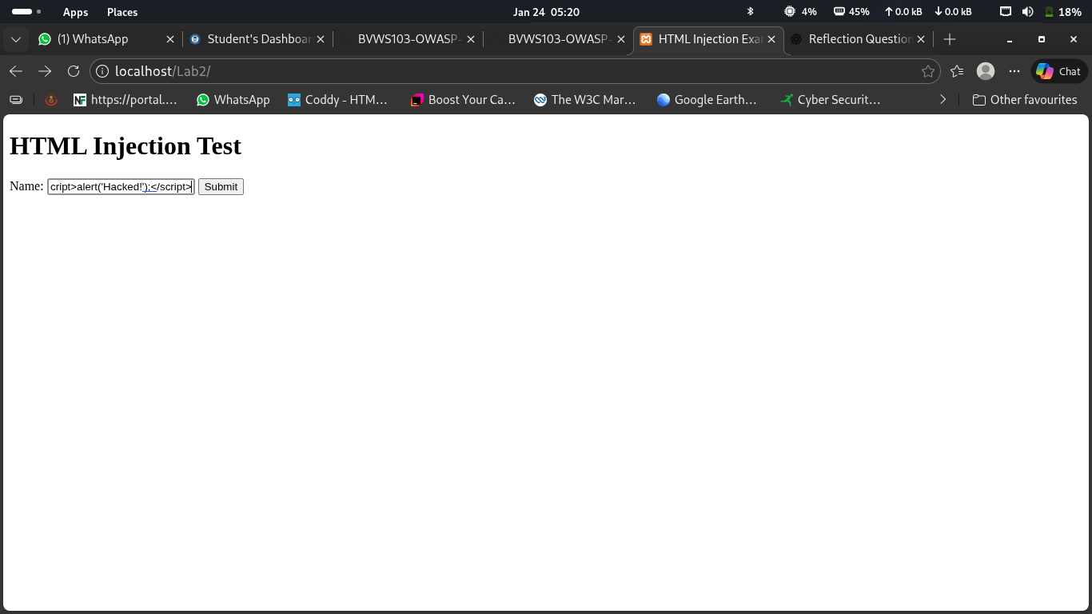

This time, the script does not execute, and instead, it shows the input displayed as text
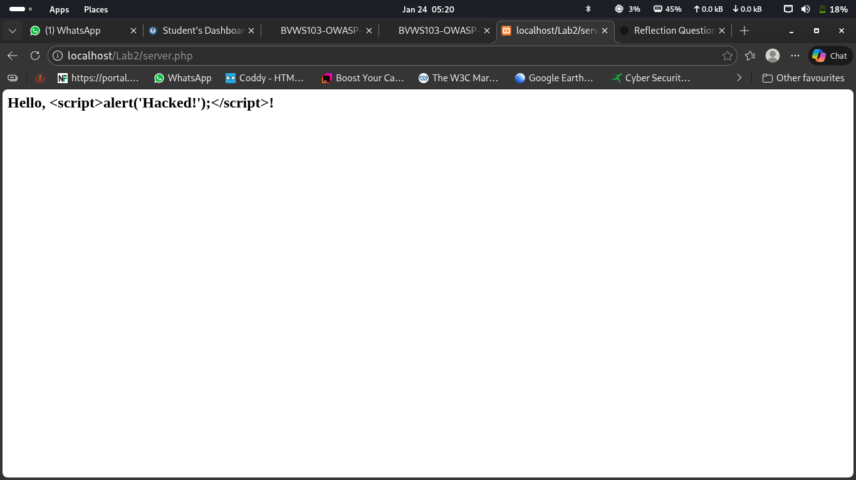

1. What happens to the malicious input after applying htmlspecialchars()?
After applying the htmlspecialchars() function, the malicious input is converted into safe text by replacing special characters with HTML entities.

2. How does this prevent the code from being executed?
htmlspecialchars() prevents execution by escaping special characters

3. How do you feel about the importance of input sanitization in web security?
Input sanitization is extremely important in web security because it protects applications from attacks such as HTML injection, XSS, SQL injection, and data manipulation. Without sanitization, attackers can exploit user input to run malicious code, steal sensitive information, or damage systems.

